## ***Practical1: Introduction and Contribution to Wikipedia***

**Description about Wikipedia:**

Wikipedia, free Internet-based encyclopaedia, started in 2001, that operates under an open-source management style. It is overseen by the non-profit Wikimedia Foundation. Wikipedia uses a collaborative software known as wiki that facilitates the creation and development of articles.

**Features:**

You may not have realized, but you've probably already used a Wiki. The most famous example most people have engaged with is Wikipedia, the free internet encyclopaedia that anyone can edit. While your company Wiki may not end up containing quite as many answers, the concept and functionality is the same.

Wikis can have a variety of uses and applications, but they usually share a few key functionalities. We'll walk you through each of these features using the Wiki in Backlog.

**Creating Account on Wikipedia:**

* Go to ==> <https://www.wikipedia.org>
* The click on the english as shown

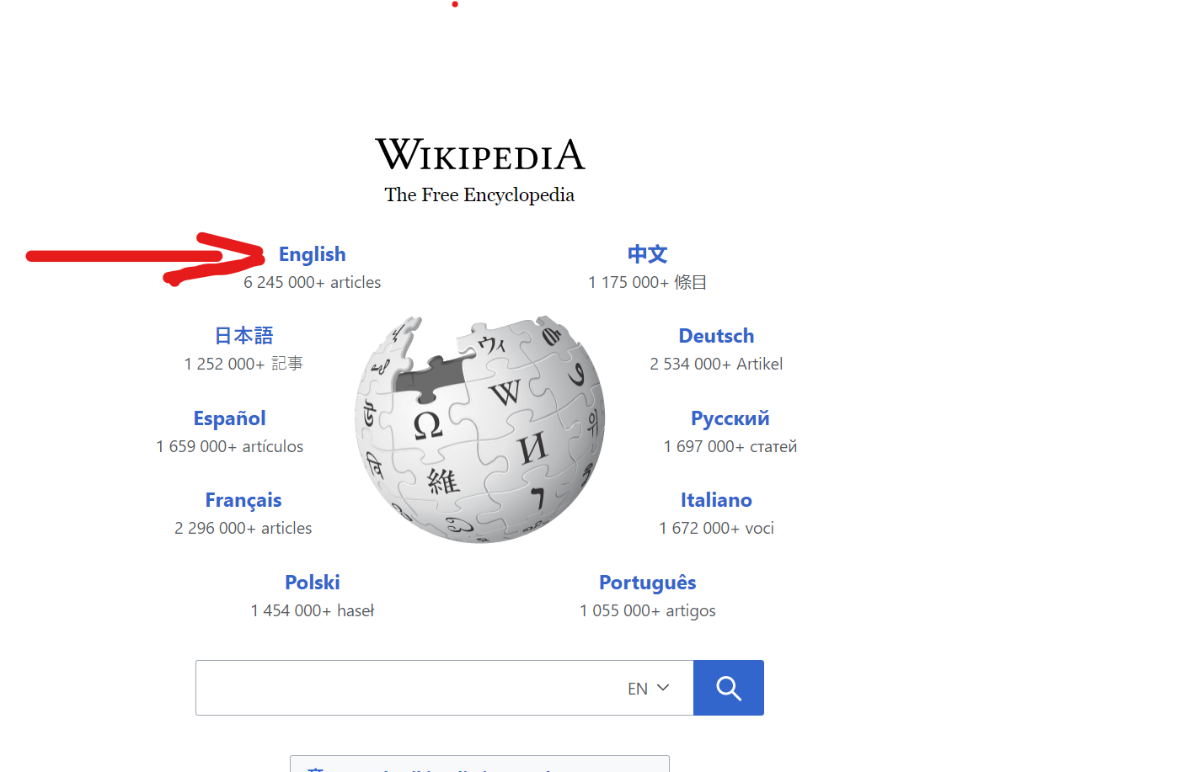

* Click on create account

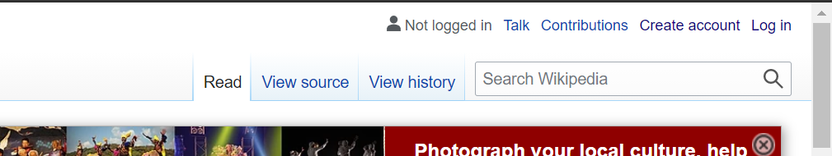

* Fill all the detail as shown in the photo

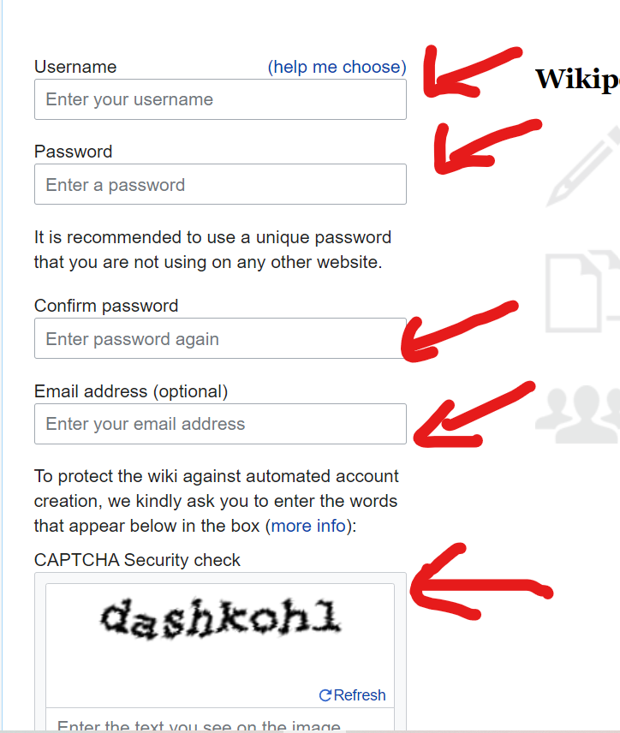

* Click on the account name and then click on the start user

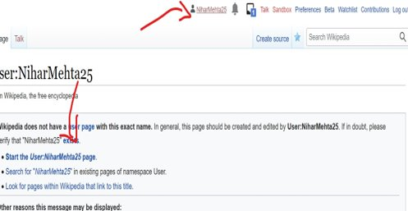

* Editing your page on Wikipedia

